Northern University of Business and Technology Khulna
Department of Computer Science and Engineering
WEEK 11: DEPLOYMENT REPORT
Project Title: AI-Powered Resume Analyzer and Career Copilot (RESUMIND)
Course Title: Mobile Computing Lab
Course Code: CSE4204
Submitted to:
Md. Riaz Mahmud
Assistant Professor
Department of Computer Science and Engineering
Northern University of Business and Technology, Khulna
Submission Date: 22 October 2026

TEAM INFORMATION SHEET
Field | Details
Official Team Name | CSE4204-8A-T05
Section | 8A
Project Title | AI-Powered Resume Analyzer and Career Copilot (RESUMIND)
Team Member List with IDs | 1. Mahammad Hasan (ID: 11220320828) - Team Leader / Frontend Developer + UI/UX Designer  2. Shanawaz Sakib (ID: 11220320916) - Core System Integration Engineer  3. Ashikur Rahman Himel (ID: 11220320833) - Database Storage & Quality Controller  4. Rasel Ratul (ID: 11220320827) - Backend Developer
Live Application Link | https://ai-resume-analyzer-psi-lime.vercel.app
GitHub Repository Link | https://github.com/mahamud894/AI_Resume_Analyzer
Figma Link | https://www.figma.com/design/Ls0B3DIjxRKrP2RIzYQxPG/AI-Resume-Analyzer?node-id=2-2&t=lFEVQCoUHt0JSumI-1

1. Live Deployment Links
RESUMIND is deployed and publicly accessible. Scan a code with a phone camera or open the links below.
  Live application  https://ai-resume-analyzer-psi-lime.vercel.app |   Source code (GitHub)  https://github.com/mahamud894/AI_Resume_Analyzer

Table 1: Submitted links
Item | URL
Live application (frontend) | https://ai-resume-analyzer-psi-lime.vercel.app
Backend API | https://resumind-api-3kpd.onrender.com/api
API health check | https://resumind-api-3kpd.onrender.com/api/health
GitHub repository | https://github.com/mahamud894/AI_Resume_Analyzer
CI status (GitHub Actions) | https://github.com/mahamud894/AI_Resume_Analyzer/actions

Please note: The backend runs on Render's free plan and sleeps after 15 minutes without traffic. The first request after that takes about 50 seconds; afterwards it responds normally. Open the health-check link once before testing.

1.1 Demo account
Examiners can create their own account in a few seconds (Sign Up or Sign in with Google), or use the team's demo account shared during the presentation. No personal data is required.

2. Hosting Architecture
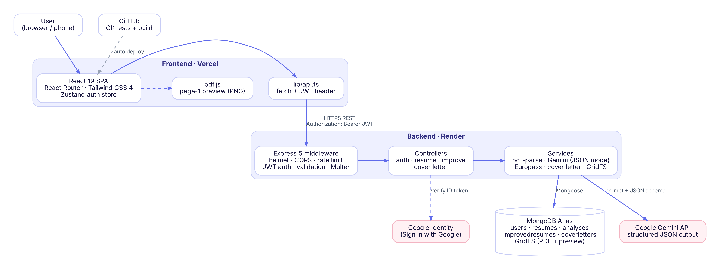
Figure 1: Deployment architecture
Table 2: Deployment requirements from the handbook and how they are met
Requirement | Our deployment
Frontend on Vercel / Netlify | Vercel — React Router app built as a static SPA (build/client), root directory frontend, configured by frontend/vercel.json
Backend on Render / Railway | Render web service resumind-api from the Blueprint render.yaml: root backend, build npm ci --omit=dev, start npm start, health check /api/health, Node 24
Database | MongoDB Atlas M0 cluster — collections + GridFS for uploaded files (Render's disk is temporary)
Environment variables in .env | Local: backend/.env and frontend/.env (git-ignored, templates in .env.example). Production: Vercel and Render dashboards
Automatic deployment | Every push to main → GitHub Actions runs tests → Vercel and Render redeploy the same commit

3. Environment Variables and Secrets
No secret is stored in the repository. Only the variable names are listed here; the values exist only in the hosting dashboards and in each developer's local .env file.
Table 3: Backend (Render)
Variable | Purpose | Where the value comes from
MONGO_URI | MongoDB Atlas connection string | Atlas → Connect → Drivers
JWT_SECRET | Signs login tokens | Generated automatically by Render (generateValue)
GEMINI_API_KEY | Google Gemini access | Google AI Studio
GOOGLE_CLIENT_ID | Verifies Google Sign-In tokens | Google Cloud Console → OAuth client
CLIENT_URL | CORS allow-list (the Vercel URL) | https://ai-resume-analyzer-psi-lime.vercel.app
NODE_ENV · TRUST_PROXY | production · 1 (correct client IP behind Render's proxy for rate limits) | render.yaml

Table 4: Frontend (Vercel)
Variable | Purpose | Value
VITE_API_URL | Address of the backend API | https://resumind-api-3kpd.onrender.com
VITE_GOOGLE_CLIENT_ID | Shows the Sign in with Google button | Same OAuth client id as the backend

3.1 Security measures for the deployment
- .env files are listed in .gitignore; only .env.example templates with empty values are committed.
- The Gemini key and database password exist only on the server; the browser receives only the public API URL and the public Google client id.
- CORS accepts requests only from the production frontend URL.
- HTTPS everywhere (Vercel and Render provide TLS certificates automatically).
- Atlas allows 0.0.0.0/0 because Render has no fixed IP; access is still protected by a strong database user password.

4. Deployment Procedure

4.1 Backend → Render
- Render → New → Blueprint → select the GitHub repository; Render reads render.yaml.
- Enter MONGO_URI, GEMINI_API_KEY, GOOGLE_CLIENT_ID and CLIENT_URL; JWT_SECRET is generated.
- Deploy and check that /api/health returns {"status":"ok"}.

4.2 Frontend → Vercel
- Vercel → Add New → Project → import the repository → Root Directory frontend.
- Add VITE_API_URL (the Render URL, no trailing slash) and VITE_GOOGLE_CLIENT_ID.
- Deploy, then set CLIENT_URL on Render to the Vercel URL and add the URL to the Google OAuth client's authorised JavaScript origins.

4.3 Continuous integration and delivery
git push origin main
│
├─▶ GitHub Actions: backend → npm ci → npm test (48 tests)
│ frontend → typecheck → build
├─▶ Render : npm ci --omit=dev → npm start → health check → live
└─▶ Vercel : react-router build (SPA) → live

5. Deployment Verification
Table 5: Checks performed on the live system
# | Check | Result
1 | Live URL opens the landing page over HTTPS on desktop and phone | Pass
2 | /api/health returns status ok | Pass
3 | Sign up, log in, log out, Sign in with Google | Pass
4 | Upload PDF → analysis result shown | Pass
5 | Europass CV, before/after score, cover letter, PDF downloads | Pass
6 | Uploaded files still available after a backend redeploy (GridFS) | Pass
7 | Request from another origin is blocked by CORS | Pass
8 | Unknown page shows the 404 page | Pass
9 | CI green on the deployed commit | Pass

5.1 Keeping the demo stable
- Wake the backend by opening /api/health 2–3 minutes before the presentation.
- Keep a resume PDF and a job description ready on the presentation laptop.
- Prepare a demo account that already contains one finished analysis, CV and cover letter.
- Keep backup screenshots (in the presentation slides) in case the internet or Gemini is unavailable.

